# Project Proposal

Study Flip

# Client

Studies Co-ordinator: Barbara Doran

Students in highschool

By

Eeyern Ng

# Introduction

## Table of Contents

Project Proposal 1

Client 1

Introduction 2

Table of Contents 2

Client Project Proposal 3

Design Brief 3

About the Client 3

Proposed Users 3

Outline of problem/need 3

Proposed Design Specification 4

Outline of the proposed solution 4

User Needs 5

Overview of functions 5

Details of the functionality and features 6

Developers needs 8

Data requirements 14

Quality Assurance 16

Project Planning report 17

Communication 17

Project management plan for STAGE 1 including: 17

# Client Project Proposal

## Design Brief

### About the Client

Miss Doran, study coordinator, wants to discover new ways of studying to assist boys at Shore Senior School

### Proposed Users

This program is for students who are studying for their exams in high school. Typically for students that do syllabus type subjects that require specific reference to detail . (Humanities such as Business Studies, Economics, Modern History, Ancient History, Legal Studies)

### Outline of problem/need

Manual Study

Sam is having such a hard time remembering all of his study notes. He has already written them out by hand but can’t seem to retain everything. It was only after a past paper that he realised he could only remember half of the content. He had thought his study notes were quite condensed and used visuals to aid study; however when it came down to the crunch, he just couldn’t do it.

Issue

The problem was that the study he was doing was ‘passive study’, which is relaxed study writing notes and reading. What Sam needs is a system that can aid him in remembering the notes, a system that can test his knowledge.

Requirements  
He would also like to have this system computer based as he has currently 6 subjects to study which rely heavily on text books. An electronic flash card system that he can easily flip through subjects to test his knowledge. Quizzes to further supplement his studies.

Image of the current system below:

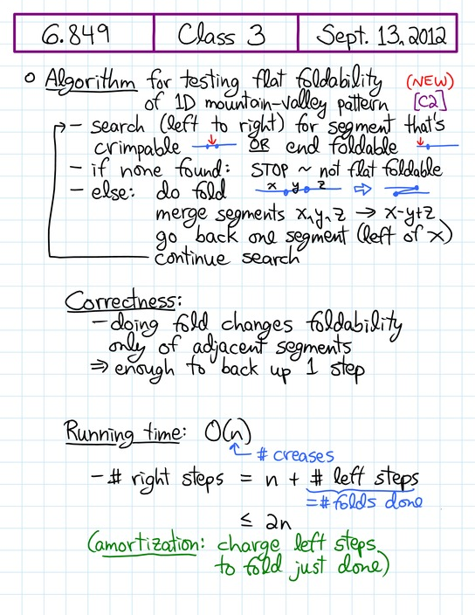

This system is an example of the ‘passive study’ that Sam is writing for his science exam.

* notes are effective however they do not assess his own knowledge.
* The notes are just condensed from his prescribed science text book.
* This example has been included to distinguish the system with the proposed solution (seen later in this document)

**Compatibility issues**

There will be no browser issues as the website design is adapted from the Twitter framework (freeware) called Bootstrap. This is compatible with all web browsers, phone browsers such as opera, android browser, iphone safari browser

**Performance issues**

As the system is designed just for the school, there will be no performance issues as there is a smaller community that this project is designed for.

## Proposed Design Specification

### Outline of the proposed solution

Miss Doran has notified program developer Eeyern about the existing study systems that are paper based. From listening to these existing study systems, Eeyern has come up with an idea to incorporate a few of these ideas and modify it to formulate a better study system. The system will be an online web based solution (coded in php and html), connected to a database and private for each student. Each student will enter their questions and answers and have the option of revising through flash cards, or a multiple choice quiz.

### User Needs

### Overview of functions

Only members can perform these functions (administrator function= “A”

1. Administration (Can perform user functions and more)
   1. Management can modify user accounts (ie. Change username, password, date of birth etc.)
   2. Management can approve categories from students
2. User management
   1. Login Screen for individuals to access own account
   2. Register for those who do not have an account (join via a form)
      1. Verification via email
      2. Verification by image recognition
      3. Information stored in database
   3. Forgot password for those who have forgotten their password details
      1. Verification by email
      2. Password sent to email from database
3. Study
   1. Student create subject and category (needs to be approved by administrator) for desired revision and organisation
   2. Students create Q and ideal answer for revision, information stored in DB
   3. Information can either be private or public for students disgression (for shared, author adds usernames to the “shared list”, once added it can be viewed by users on the list). Creation of study questions are set to private by default.
   4. During study, answers are hidden until user presses ‘flip button’
   5. Students can add, delete, modify study questions
   6. Students write down answer (as the HSC is a written based examination, therefore after writing the answer on paper, students click the ‘flip button’ and compare their answer with the model answer
4. Test
   1. Students create subject and category (needs to be emailed and approved by administrator) for desired multiple choice test
   2. Students create questions and answers, information stored in DB (pool of Q&A’s)
   3. Prior to the test, students see the maximum number of questions that they can do, in a separate text box they specify how many questions they want to complete for that test.
   4. Questions are randomised.
   5. During the test, students read the question and click the best answer
   6. As the student clicks next, the next question made comes straight up
   7. Timer countdown for students to work with multiple choice questions under pressure
   8. Students can add, delete, modify test questions and answers
   9. Tests can be shared or private (for shared, author adds usernames to the “shared list”, once added it can be viewed by users on the list). Creation of tests are set to private by default.
5. The system
   1. Security: Passwords to database
   2. Specified data type and character limit in forms (to prevent access and modification of database by use of code) . This can be seen in the data dictionaries.

## Overall storyboard

# Storyboard – {Login} and {creation of questions (start page)}

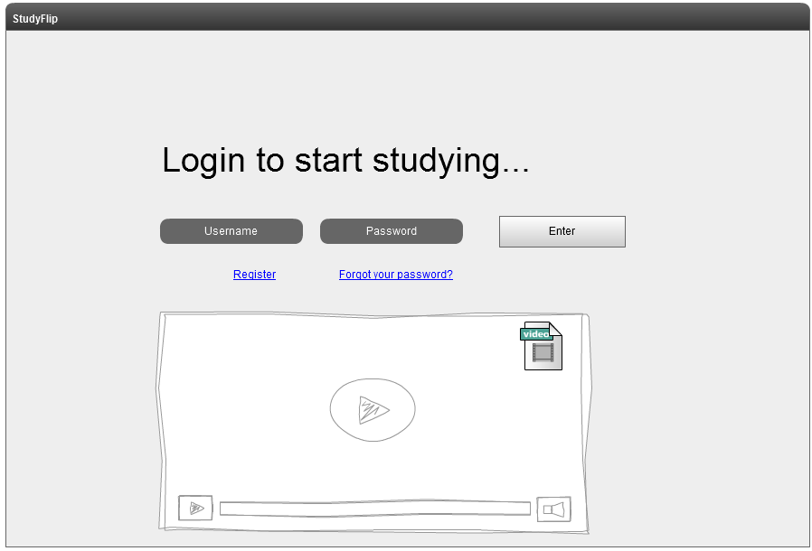

User is presented with a login screen

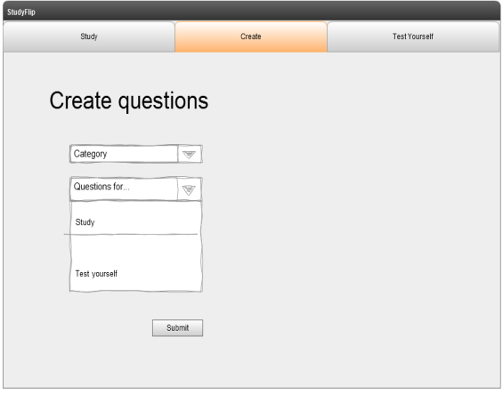

Student has the option of creating questions for study revision or multiple choice test

|  |  |
| --- | --- |
| * When creating questions for revision, students have subject text book in front of them and type in the question and answer, they can create more by pressing ‘create more’ or finish by saying submit | * Student types question and possible multiple choice answers, clicking on the letter to indicate the right answer |
| * Student selects the topic of what they want to revise | * Students select the topic of nature of the test |
| Student is presented with a question, they write down the answer to the question then presses flip for the model answer | Time starts once test starts, randomised question is displayed and student can choose the right answer. They then click the arrow for the next question |
| Student clicks flip once finished writing answer down on paper; then compares answer with model answer | Results page is shown, with incorrect answers, percentage score and time taken to complete test |

# flow of the program – Creation of Study (left column) and Test Yourself (right column)

# functionality and features

### 

(+) place holder (documentation for user) to show where to type their username and password

(+) Register button for non members

(+) Register will send confirmation of account creation to email for verification

(+) Forgot your password will have a image verification and secret question, if both right then password is emailed to the entered email.

(+) If user gets password wrong or insufficient data entered in one of the fields, system says “username/password is incorrect”

(+) Video on login screen to show features of the study program and a mini tutorial on how to use it

Figure : Student login page to access study notes

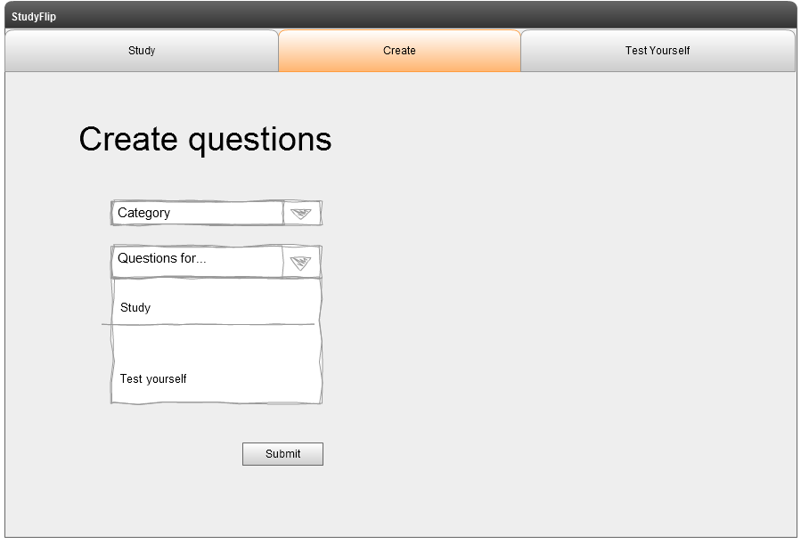

(+) Preset categories on drop down menu (categories are created by teachers and admin only, however students can email admin requesting new categories)

(+) Drop down menu for students wanting to create study questions and model answers, and multiple choice tests

Figure : Student create questions page. Study or Test Yourself

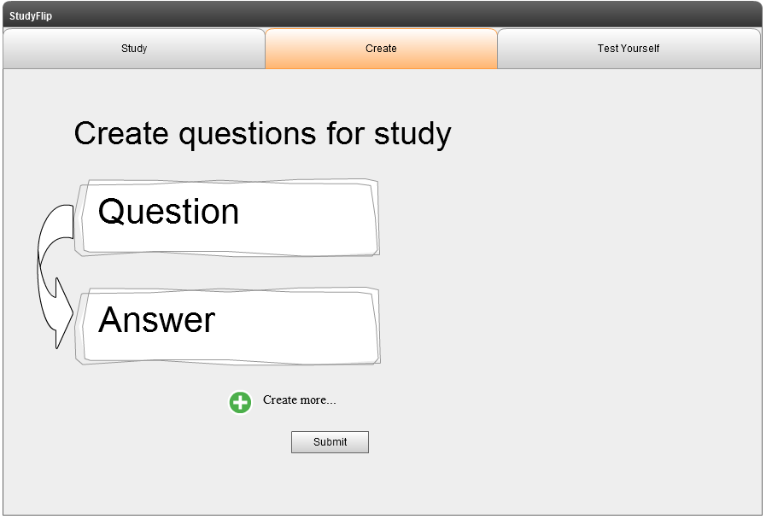

(+) Placeholders for user documentation, where users click on question to type in a question, and answer to write a model answer from the textbook

(+) Create more button opens another question/answer for more study question and answers.

(+) Users will have the option of going back to modify questions and answers (not in screen design yet)

(+) Submit saves the set of question and answers “successful” message pops up and takes user back to home page.

Figure : Student creates questions for study on selected topic from category in {Figure 2}

### 

(+) On study page/tab, user selects topic of sets that have already been made.

(+) Study cards will only be shown privately to user unless if user wants to make study cards public.

(+) Page will elongate up to 10 topics per page, navigation at the bottom

Figure : After creating study questions, student clicks on study tab and presented topic selection

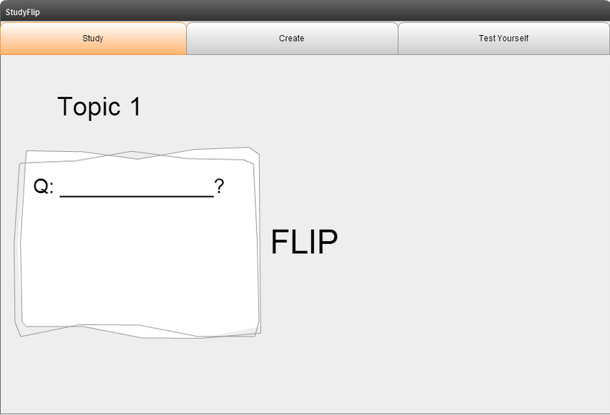

(+) Topic shown at the header

(+) Question pops up and user writes down answer to question on a notebook (handwritten because HSC examinations done all by handwriting)

(+) User clicks on the flip button after having written the response

Figure : Student is presented the first question, then on a sheet of paper the student writes an answer

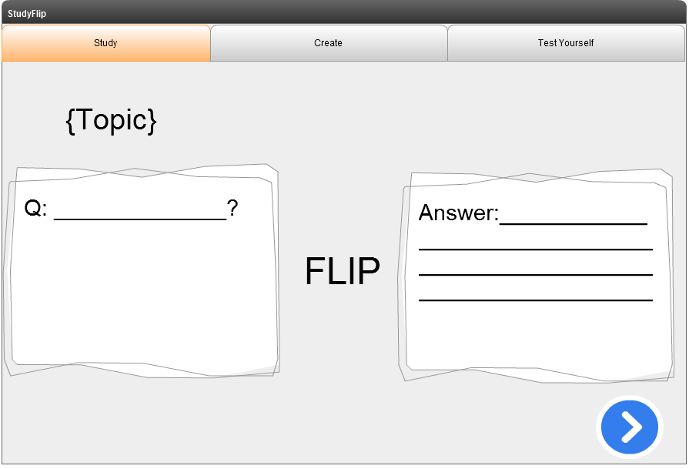

(+) User sees answer and question

(+) Corrections made will be written down in a different coloured pen (recommended red) to tell user of detail that needs to be included next time

(+) Big arrow for next question

Figure : Student clicks flip and is shown the answer. Student then looks at the answer and clicks next when finished

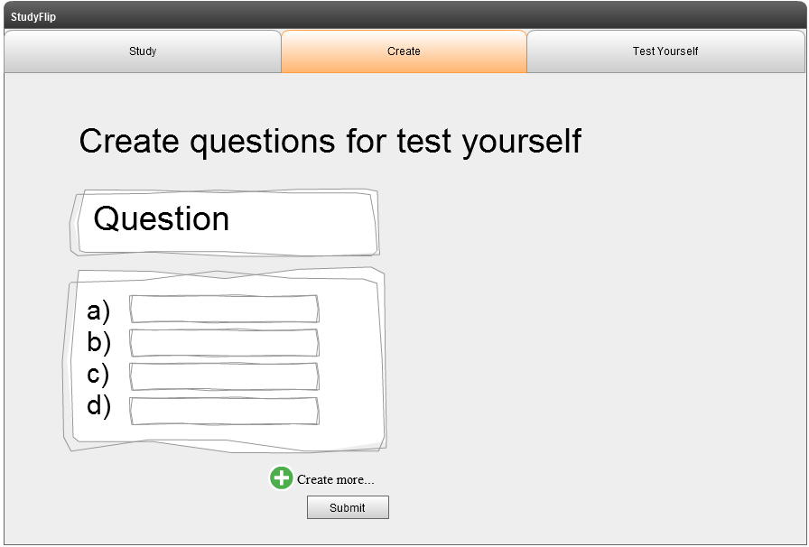

(+) Placeholders for user documentation, where users click on question to type in a question, and answer to write a model answer from the textbook

(+) Create more button opens another question/answer for more study question and answers.

(+) Users will have the option of going back to modify questions and answers (not in screen design yet)

(+) User clicks on the correct answer (not in screen design yet)

(+) Submit saves the set of question and answers “successful” message pops up and takes user back to home page.

Figure : Student clicks create questions and enters questions and multiple choice answers

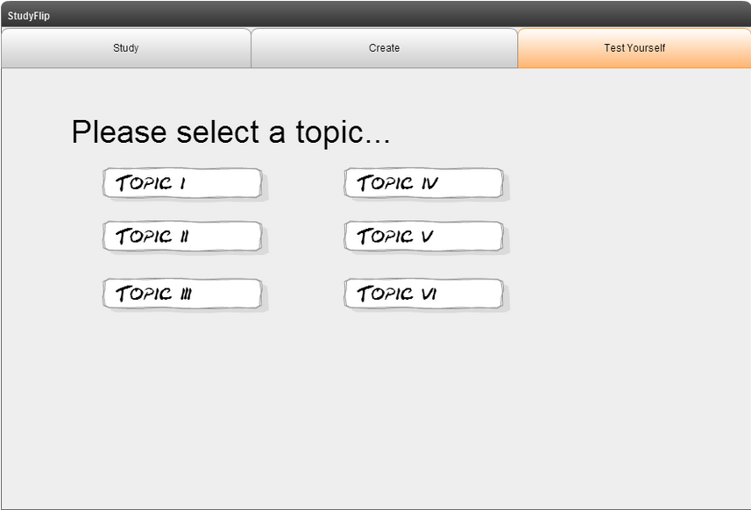

(+) On study page/tab, user selects topic of sets that have already been made.

(+) Study cards will only be shown privately to user unless if user wants to make study cards public.

(+) Page will elongate up to 10 topics per page, navigation at the bottom

Figure : After creating a test yourself topic, user clicks on test yourself and is presented the topic selection page

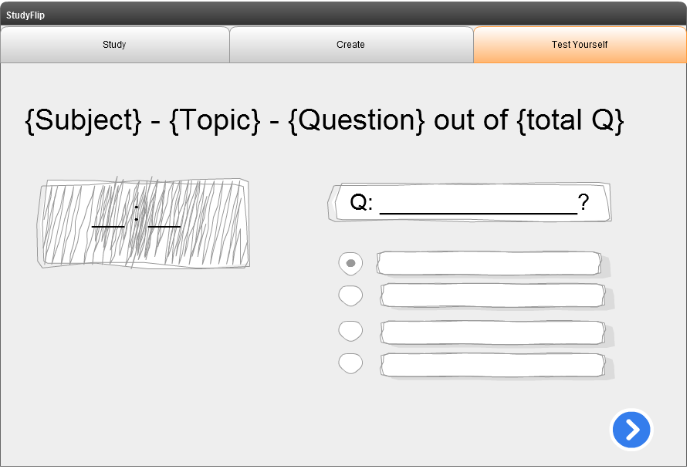

(+) As soon as test starts, timer starts and stops until test is finished

(+) Question pops up and user clicks on the answer that they see fit

(+) Arrow to submit question

(+) User cannot go back to previous question and is therefore advised to think carefully

Figure : Once test starts, timer can be shown with questions and multiple choice answers.

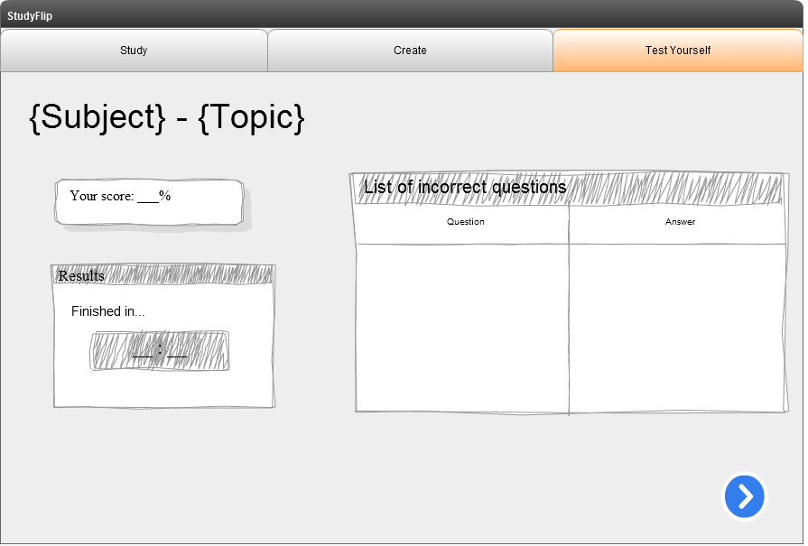

(+) Results page with subject and topic as header

(+) Percentage is calculated of correct:incorrect

(+) List of incorrect questions listed on the right

(+) Finishing time shown

(+) Arrow takes user to home page

Figure 10: Results page upon completion of the test.

Developer’s needs

### Data requirements-Data dictionary

Table 1: tbl_category

|  |  |  |  |
| --- | --- | --- | --- |
| Identifier | Data Type | Description | Example |
| Catid | int(20) | Category Identifier, primary key, auto increment | 1,2,3,4,5,6 |
| Categoryname | varchar (45) | Name of category | History, Music, English |

Table 2: tbl_topic

|  |  |  |  |
| --- | --- | --- | --- |
| Topicid | int(20) | Topic Identifier, primary key, auto increment | 1,2,3,4,5,6 |
| Sameid | int(20) | Category Identifier, primary key | 1,2,3,4,5,6 |
| Topicname | varchar (45) | Name of topic | World War 2, Musical Instruments, Belonging |

Table 3: tbl_study

|  |  |  |  |
| --- | --- | --- | --- |
| Identifier | Data Type | Description | Example |
| Studyid | int(20) | Study Identifier, primary key, auto increment | 1,2,3,4,5,6 |
| Subnameid | int(20) | Topic Identifier | 1,2,3,4,5,6 |
| Studyq | varchar (100) | Study question | Identify the 4 key business functions in any business |
| Studydesc | varchar (200) | Answer to the study question | The four key business functions are Business Operations, Marketing, Finance and Human Resources |

Table 4: tbl_revision

|  |  |  |  |
| --- | --- | --- | --- |
| Identifier | Data Type | Description | Example |
| Studyid | int(20) | Study Identifier | 1,2,3,4,5,6 |
| Subnameid | int(20) | Topic Identifier | 1,2,3,4,5,6 |
| Revisionid | int(20) | Revision Identifier, auto increment | 1,2,3,4,5,6 |
| Revision | varchar (100) | Study question | The software development life cycle follows which of the following steps |
| revision1 | varchar(100) | Answer 1 | Understanding the problem, designing the solution …. |
| revision2 | varchar(100) | Answer 2 | circle |
| revision3 | varchar(100) | Answer 3 | square |
| revision4 | varchar(100) | Answer 4 | None of the above |
| Rightanswer | varchar(100) | Selects answer | a,b,c,d |
| Userid | int(20) | User identifier | 1,2,3,4,5,6 |
| Time | num(30) | Timer during the test | 1:23 |

Table 5: tbl_users

|  |  |  |  |
| --- | --- | --- | --- |
| Identifier | Data Type | Description | Example |
| Userid | int(20) | User Identifier, Auto increment | 1.2.3.4.5.6 |
| Username | varchar(100) | Login name | DavidRocksMySocks |
| Password | varchar(100) | Password | HeActuallyDoesnt |
| Level | int(1) | Level of access/authorization | 1 |

## Quality Assurance

1. The system is simplistic so that it can be user friendly for students to ASSIST in study, and not contract from study.
2. Software can allow students to create study revision for themselves
3. Database is secure so that information cannot be leaked.
4. Good documentation of the project to ensure further development in future versions of the software.
5. The software isn’t too large a file to download
6. Uses small amounts of processing.

# Project Planning report

### Communication

To communicate with client, there will be a short discussion held every week, to discuss any issues, completion of tasks and any queries that need to be addressed. These meetings are run by the project developer, Eeyern. Once program is launched, there will be a closed survey created for feedback with design issues and further additions to the project.

### Project management plan for STAGE 1 including:

* **Project tasks**

Action list is located in Stage 1 🡪 Project Management 🡪”action.txt”

* **Scheduling** of the project tasks, using a Gantt chart>>

Gantt Chart is located in Stage 1 🡪 Project Management 🡪”project.mpp” and will be converted to project.pdf upon completion of project

* **Electronic work log**

Work log is located in Stage 1 🡪 Project Management🡪”log.txt”

* **Risk analysis** for the project including:

The main contributing factors that would affect progress of the system would be:

1. Developers’ lack of knowledge
2. Poor planning
3. Poor design
4. Communication with the client
5. Scope of the project being too big in relation to the date of submission
6. User involvement
7. Involvement of management

By preventing poor planning, sequence and scheduling tools such as a Gantt chart, action lists, and work logs.